NAME:Rishik JK
REG.NO :192511052

CSA1702-ARTIFICIAL INTELLIGENCE
LAB EXPERIMENT

Aim
To write a Python program to solve the Map Coloring Problem using Constraint Satisfaction Problem (CSP) and Backtracking Algorithm.

Algorithm
- Start the program.
- Define the regions and available colors.
- Define the neighboring regions of each region.
- Select a region and assign a color.
- Check whether adjacent regions have different colors.
- If the color is valid, move to the next region.
- Otherwise, try another color using backtracking.
- Repeat until all regions are colored.
- Display the final solution.
- Stop the program.

Output:
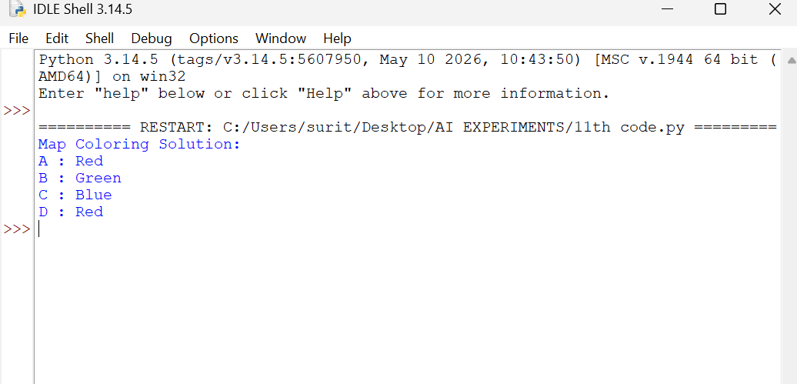
Result: Thus, the Python program for Map Coloring using Constraint Satisfaction Problem (CSP) and Backtracking Algorithm was successfully implemented and executed.

